Machine Learning
The What?
Machine Learning (ML) is a branch of artificial intelligence (AI) that enables computers to learn from data and make decisions or predictions without being explicitly programmed. Instead of following a fixed set of instructions, ML models identify patterns in data and improve their performance over time.
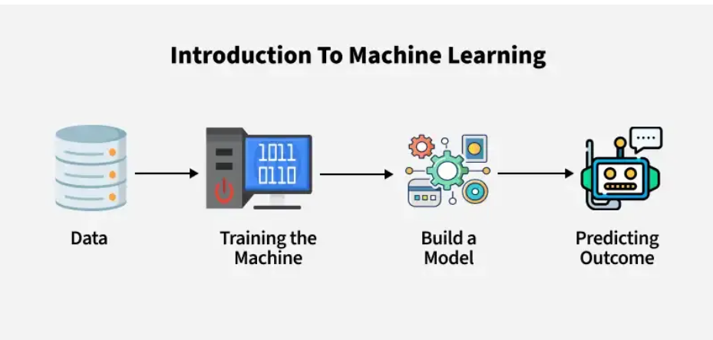
The Why
- Automation: Reduces human effort by automating tasks.
- Data-Driven Decisions: Helps in making accurate predictions.
- Improves Over Time: The model learns and enhances its accuracy with more data.

Difference between Explicit & Implicit Improgramming

Explicit Programming :-
Involves the Computer clear & specific instructions about exactly what to do. The Programmer defines every rule and step in detail. Every action is manually coded.
eg: if you want to sort a list of numbers in ascending order, you would explicitly write out the steps, such as comparing two numbers and swapping them if necessary.

Implicit Programming :-
Implicit programming is (often used in machine learning) allows the computer to learn from data and figure out the rules on its own. you don't Explicitly program each step the System learns patterns and Behaviors through Examples and make decisions based on that learning.
Eg:- If you want to teach a computer to recognize whether an image is cat or a dog. You don't tell it exactly how to identify the animal instead you provide many images of cats and dogs and the computer learns to recognize patterns in those images on its own.
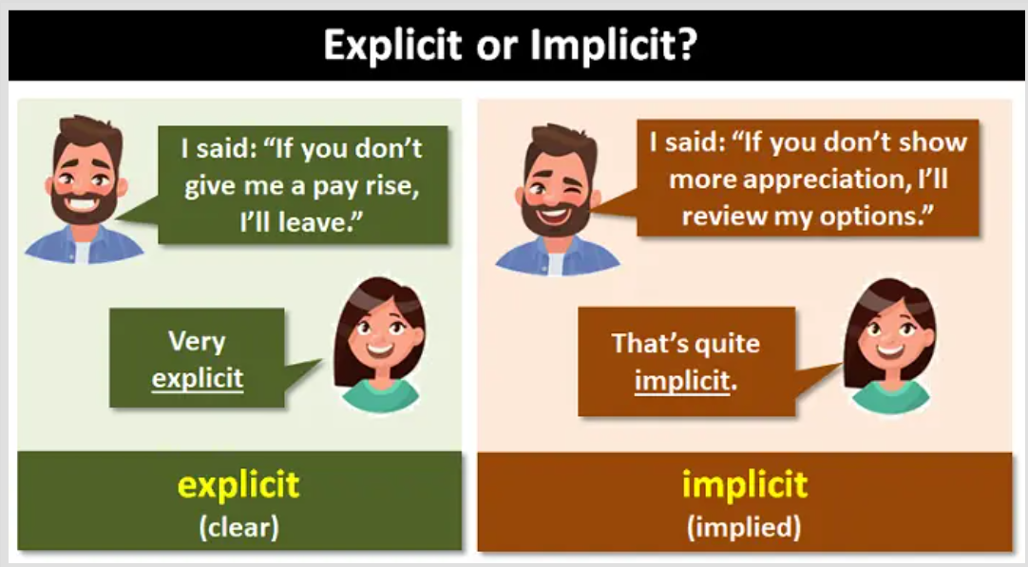
Explicit :- Do this, and do it this way
Implicit :- Learn from this data and figure out how to do it

Types of Machine Learning
- Supervised machine learning
- Unsupervised machine learning
- Self-supervised machine learning
- Reinforcement learning
- Semi-supervised learning

Supervised machine learning

Supervised Machine Learning is a type of machine learning where the model is trained on labeled data. In this approach, the algorithm learns from a dataset that includes both input features and the corresponding correct output labels. The goal is to learn a mapping from inputs to outputs that can be used to predict the labels for new, unseen data.

Key Concepts:

- Labeled Data: The training dataset consists of input-output pairs, where the output (label) is the correct answer or target value.
- Training: The model learns by minimizing a loss function, which measures the difference between the predicted output and the actual label.
- Prediction: Once trained, the model can predict outputs for new inputs.

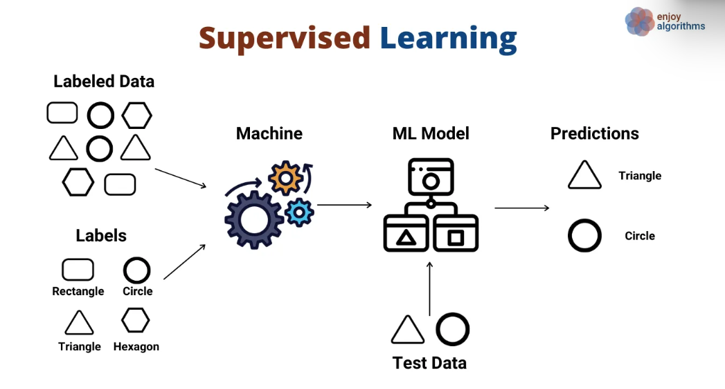
Types of Supervised Learning:

- Classification: The output is a category or class label. Examples include:
  - Binary classification (e.g., spam detection: spam or not spam).
  - Multi-class classification (e.g., image recognition: cat, dog, bird).
  - Algorithms: Logistic Regression, Support Vector Machines (SVM), Decision Trees, Random Forests, Neural Networks.

- Regression: The output is a continuous value. Examples include
  - Predicting house prices.
  - Forecasting stock prices.
  - Algorithms: Linear Regression, Ridge Regression, Lasso Regression, Neural Networks.

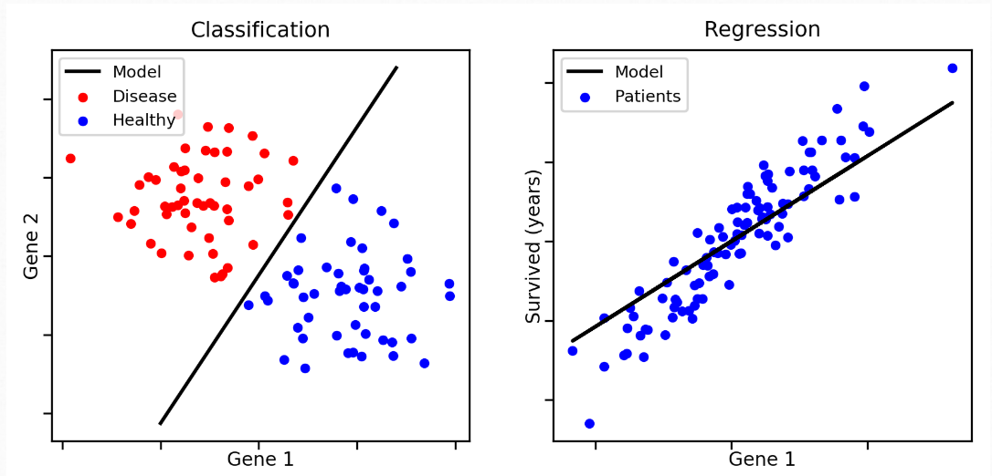

Unsupervised machine learning

Unsupervised Machine Learning Overview
Unsupervised machine learning is a type of machine learning where the model is trained on unlabeled data. Unlike supervised learning, there are no predefined output labels. The goal is to discover hidden patterns, structures, or relationships within the data.

Types of Unsupervised Learning

- Clustering:
  - Groups similar data points together based on their features.
  - Examples:
    - K-Means Clustering
    - Hierarchical Clustering
    - DBSCAN (Density-Based Spatial Clustering of Applications with Noise)

- Dimensionality Reduction:
  - Reduces the number of features while preserving important information.
  - Examples:
    - Principal Component Analysis (PCA)
    - t-SNE (t-Distributed Stochastic Neighbor Embedding)
    - Autoencoders

- Association Rule Learning:
  - Discovers relationships or associations between variables in large datasets.
  - Examples:
    - Apriori Algorithm
    - FP-Growth (Frequent Pattern Growth)

- Anomaly Detection:
  - Identifies rare or unusual data points that deviate from the norm.
  - Examples:
    - Isolation Forest
    - One-Class SVM

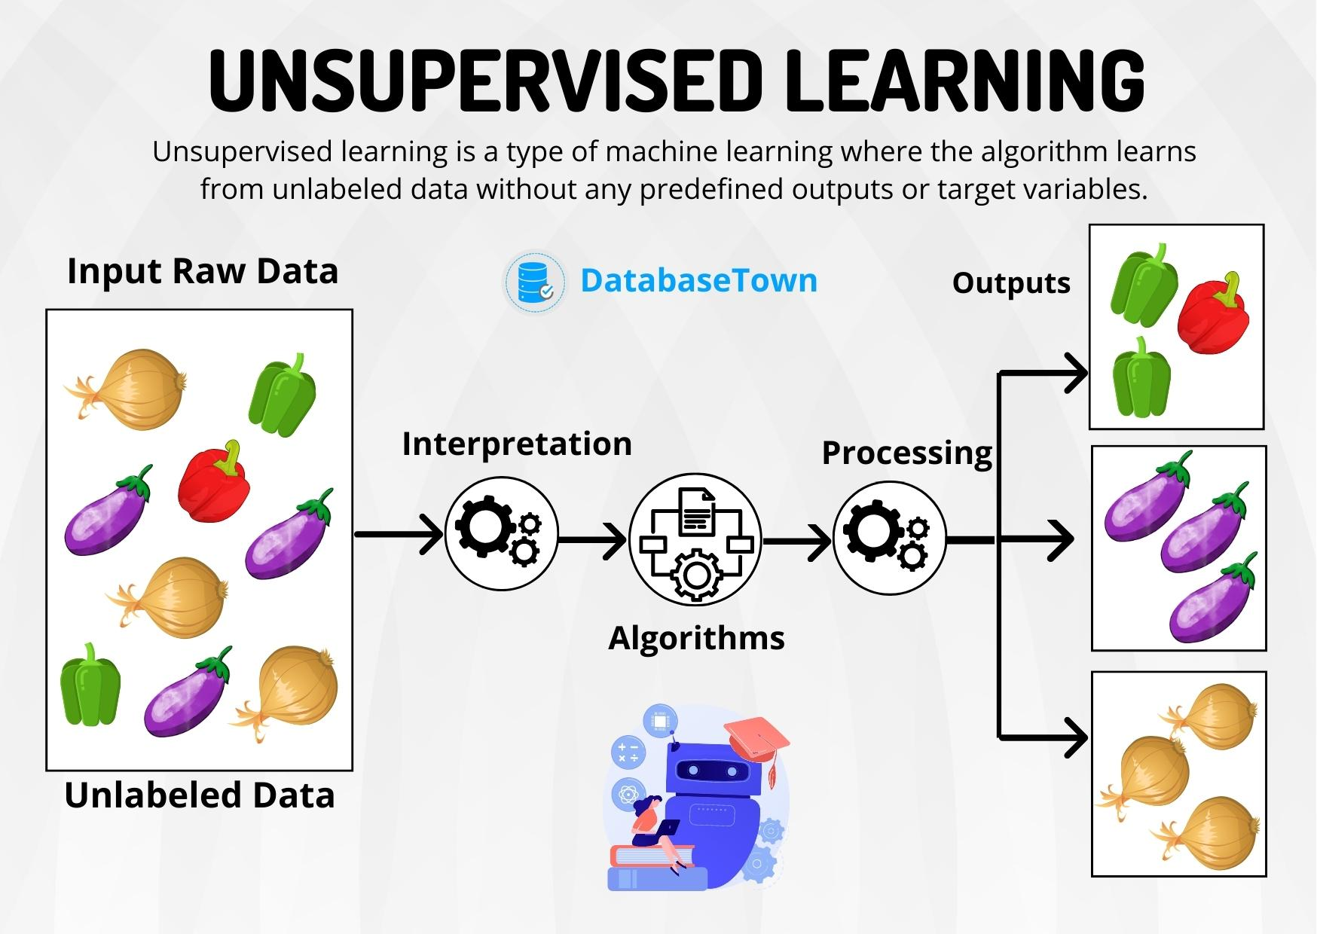

Self-supervised machine learning

Self-supervised learning is a type of machine learning that falls between supervised and unsupervised learning. It uses the structure or inherent properties of the data itself to generate pseudo-labels for training, rather than relying on manually labeled data. The goal is to learn meaningful representations of the data that can be used for downstream tasks.

Key Idea
- The model is trained to predict part of the input data from other parts of the input data. For example:
  - Predicting missing words in a sentence (e.g., BERT in NLP).
  - Predicting the rotation angle of an image.
  - Filling in missing parts of an image (e.g., inpainting).

Types of Self-Supervised Learning
- Contrastive Learning:
  - Learns representations by contrasting similar and dissimilar data points.
  - Examples:
    - SimCLR (Simple Framework for Contrastive Learning of Representations)
    - MoCo (Momentum Contrast)

- Generative Modeling:
  - Learns to generate or reconstruct data, often using autoencoders or GANs (Generative Adversarial Networks).
  - Examples:
    - Variational Autoencoders (VAEs)
    - Masked Autoencoders (MAE)

- Predictive Learning:
  - Predicts one part of the data from another part.
  - Examples:
    - BERT (Bidirectional Encoder Representations from Transformers) in NLP.
    - Predicting future frames in video data.

- Clustering-Based Methods:
  - Uses clustering techniques to generate pseudo-labels for training.
  - Examples:
    - DeepCluster
    - SwAV (Swapping Assignments between Views)

Reinforcement learning

Reinforcement Learning is a type of machine learning where an agent learns to make decisions by interacting with an environment. The agent performs actions, receives feedback in the form of rewards or penalties, and aims to maximize cumulative rewards over time. Unlike supervised learning, there is no labeled dataset; instead, the agent learns through trial and error.

Key Components of Reinforcement Learning
- Agent: The learner or decision-maker.
- Environment: The world in which the agent operates.
- State (s): The current situation or configuration of the environment.
- Action (a): A move or decision made by the agent.
- Reward (r): Feedback from the environment after an action is taken.
- Policy (π): A strategy that the agent uses to decide actions based on states.
- Value Function: Estimates the expected cumulative reward from a state or action.
- Q-Value (Q-function): Measures the expected reward for taking an action in a state and following the policy thereafter.

Types of Reinforcement Learning
- Model-Based RL:
  - The agent builds a model of the environment to predict outcomes of actions.
  - Examples:
    - Dyna-Q
    - Monte Carlo Tree Search (MCTS)
- Model-Free RL:
  - The agent learns directly from interactions with the environment without building a model.
  - Examples:
    - Q-Learning
    - SARSA (State-Action-Reward-State-Action)
- Value-Based RL:
  - Focuses on learning the value function to derive the optimal policy.
  - Examples:
    - Deep Q-Networks (DQN)
    - Value Iteration
- Policy-Based RL:
  - Directly learns the policy that maps states to actions.
  - Examples:
    - REINFORCE Algorithm
    - Proximal Policy Optimization (PPO)
- Actor-Critic Methods:
  - Combines value-based and policy-based approaches.
  - The actor learns the policy, while the critic evaluates the actions.
  - Examples:
    - Advantage Actor-Critic (A2C)
    - Asynchronous Advantage Actor-Critic (A3C)
- Inverse Reinforcement Learning (IRL):
  - The agent learns the reward function by observing expert behavior.
  - Used in imitation learning.

Reinforcement learning is widely used in areas like robotics, game playing (e.g., AlphaGo), autonomous vehicles, and recommendation systems. It excels in scenarios where an agent must learn to make sequential decisions in dynamic environments.
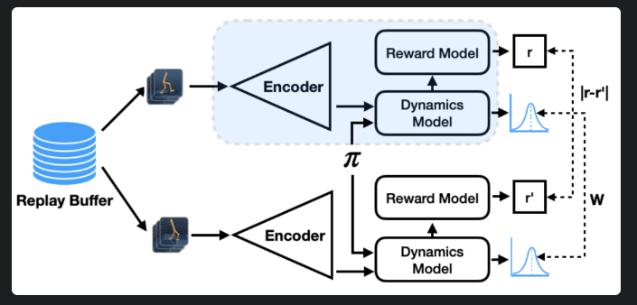

Semi-supervised learning

Semi-Supervised Learning Overview
Semi-supervised learning is a type of machine learning that combines a small amount of labeled data with a large amount of unlabeled data during training. It bridges the gap between supervised learning (which requires fully labeled data) and unsupervised learning (which uses no labels). The goal is to improve learning accuracy and reduce the reliance on expensive labeled data.
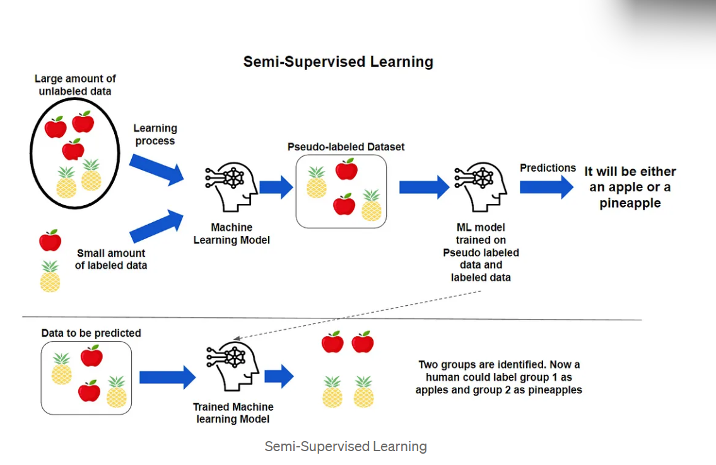

Key Idea
- Leverages the structure or patterns in the unlabeled data to enhance the model's performance, while using the labeled data to guide the learning process.

Types of Semi-Supervised Learning
- Self-Training:
  - The model is initially trained on the labeled data, then used to predict labels for the unlabeled data.
  - High-confidence predictions are added to the labeled dataset, and the process repeats.
- Co-Training:
  - Multiple models are trained on different views or features of the data.
  - Each model labels the unlabeled data for the other, improving overall performance.
- Graph-Based Methods:
  - Data points (labeled and unlabeled) are represented as nodes in a graph, and edges represent similarities.
  - Labels are propagated from labeled nodes to unlabeled nodes based on graph structure.
- Generative Models:
  - Models like Generative Adversarial Networks (GANs) or Variational Autoencoders (VAEs) generate synthetic data to augment the labeled dataset.
- Consistency Regularization:
  - Encourages the model to produce consistent predictions for the same input under different perturbations or augmentations.
  - Examples:
    - Mean Teacher
    - FixMatch
- Pseudo-Labeling:
  - The model generates pseudo-labels for unlabeled data and treats them as ground truth for further training.

Semi-supervised learning is particularly useful in domains where labeled data is scarce or expensive to obtain, such as medical imaging, speech recognition, and natural language processing (NLP). It allows models to achieve better performance by effectively utilizing both labeled and unlabeled data.

Machine Learning Development Life Cycle

1. Problem Definition

- clearly define the business or technical problems you aim to solve
- Identity success metrics and constraints (eg:- Accuracy,Speed,Budget).
- Understand data availability and stakeholders needs

Key outputs:

- Problem statement
- Sucress criteria
- Initial hypotheses.

Data Collection

- Gather relevant data from diverse Sources (databases, APIs, Web Scraping, sensors, etc)
- Ensure data is domain representative of the problem domain

Key Consideration:

- Data privacy and security
- Licensing and Compliance.

Data Preprocessing

- Clean and prepare the data for analysis.
- Handle missing, noisy or inconsistent data.
- Perform Exploratory data analysis (EDA) to understand patterns and distributions.

Key steps:

- Data cleanin cleaning
- Feature Scaling, encoding & Engineering
- Splitting data into training, validation & test set

Model Development

- Select and experiment with different ML algorithms (eg linear regression, decision trees, neural networks).
- Train the model using the training dataset. Fine-tune hyperparameters to optimize performance

Key Activities:

- Algorithm selection.
- Model Architecture design
- Training and validation.

Model Evaluation

- Assess model performance using metrics like accuracy, precision recall, F1-Score, or mean Squared error (MSE), depending on the task.
- Test the model on was unseen data to varity its generalizability.

Key outputs:

- Performance metrics
- Confusion matrix, ROC Curves etc.

Model Deployment

- Integrate the model into the production environment (eg APIs, web apps, mobile apps)
- Set up pipelines for real-time or batch predictions

Key Steps:

- Deployment architecture design
- model containerization (using Docker).
- monitoring setup

Monitoring and Maintenance

- Continuously monitor model performance for concept drift, data drift and biases
- Update the model as required based on new data or changing requirements.

Key Activities.

- Performance tracking
- Retraining with new data
- Incident handling

Model Explainability and compliance.

- Ensure transparency in the models prediction for stake holders
- Adhere to ethical Af practices and legal regulations.

Key Tools:

- SHAP, LIME (for Interpretability)
- Compliance checks for GDPR, CCPA ek.

Continuous Improvement

- Iterate on the model and pipeline to improve performance.
- Incorporate beedback from stakeholders and end-users.

Key Considerations:
- Scalability
- Automation of pipelines (using CICD).

Regression Problem in General

Regression is a type of supervised learning problem where the goal is to predict a continuous numerical value based on input features. The output is a real number, and the model learns the relationship between the input variables and the target variable.

Key Characteristics:
- Output: Continuous value (e.g., price, temperature, age).
- Objective: Minimize the error between predicted and actual values.
- Evaluation Metrics: Mean Squared Error (MSE), Root Mean Squared Error (RMSE), Mean Absolute Error (MAE), R-squared.

Examples:

- Predicting house prices based on features like size, location, and number of rooms.
- Forecasting stock prices or sales.
- Estimating the temperature based on weather data.

Common Algorithms:
- Linear Regression
- Polynomial Regression
- Ridge Regression
- Lasso Regression
- Support Vector Regression (SVR)
- Decision Tree Regression
- Neural Networks

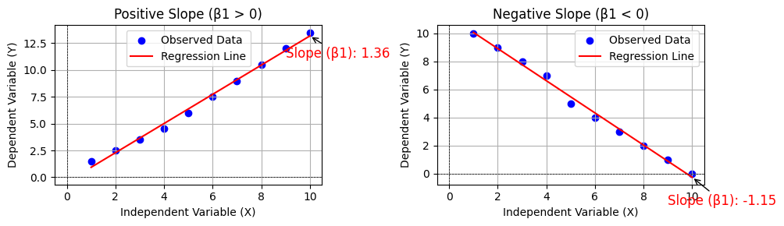

Classification Problem in General

Classification is another type of supervised learning problem where the goal is to predict a discrete class label or category based on input features. The output is a class or category, and the model learns to separate the data into distinct classes.

Key Characteristics:
- Output: Discrete label (e.g., spam/not spam, cat/dog/bird, high/medium/low risk).
- Objective: Assign the correct class label to each input.
- Evaluation Metrics: Accuracy, Precision, Recall, F1-Score, Confusion Matrix.

Examples:
- Email spam detection (spam or not spam).
- Image classification (e.g., identifying objects in images).
- Medical diagnosis (e.g., disease or no disease).
- Sentiment analysis (positive, negative, neutral).
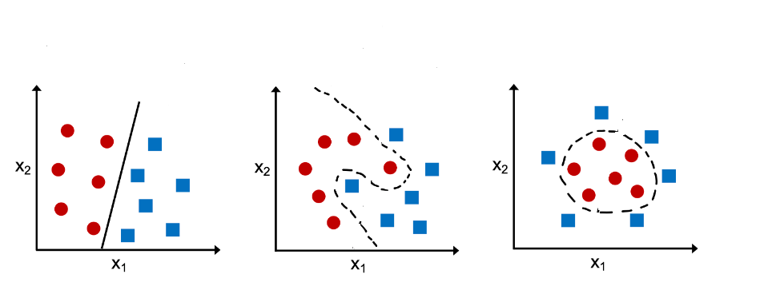

Common Algorithms:
- Logistic Regression
- Support Vector Machines (SVM)
- Decision Trees
- Random Forests
- K-Nearest Neighbors (KNN)
- Naive Bayes
- Neural Networks

Key Differences Between Regression and Classification
Aspect | Regression | Classification
Output Type | Continuous value | Discrete class label
Goal | Predict a quantity | Assign a category
Evaluation Metrics | MSE, RMSE, MAE, R-squared | Accuracy, Precision, Recall, F1-Score
Examples | House price prediction, temperature forecasting | Spam detection, image classification

Cross-Validation (CV)

Cross-Validation (CV)

Cross-validation is a technique used to assess the generalization ability of a model by splitting the dataset into multiple subsets. The model is trained on some of the subsets and tested on the remaining ones.
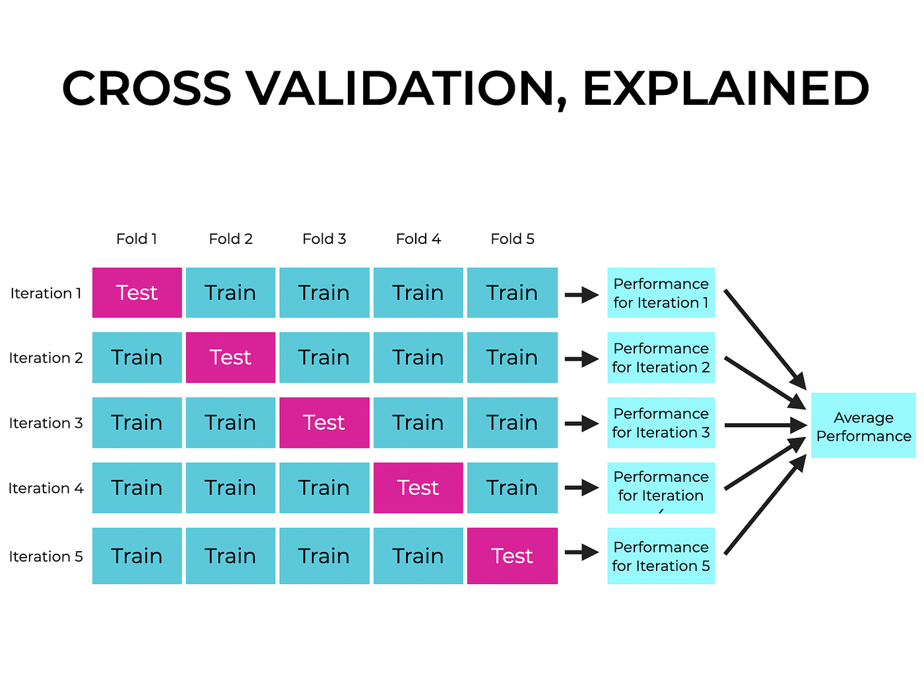
📌Types of Cross-Validation:

- K-Fold Cross-Validation: The dataset is divided into K equal parts; the model trains on K-1 parts and tests on the remaining one. This process repeats K times.

- Stratified K-Fold: Ensures class distribution remains consistent across folds (useful for imbalanced datasets).

- Leave-One-Out (LOO) CV: Each sample is used as a single test set, while the rest are used for training.

- Leave-P-Out CV: Similar to LOO but uses P samples as the test set.
💡 Usage: Helps in preventing overfitting and ensures robust model evaluation.

Out-of-Bag (OOB) Score

Out-of-Bag (OOB) Score
OOB validation is a technique specific to ensemble methods like Random Forest. Instead of splitting the dataset manually, OOB validation relies on Bootstrap Aggregation (Bagging).

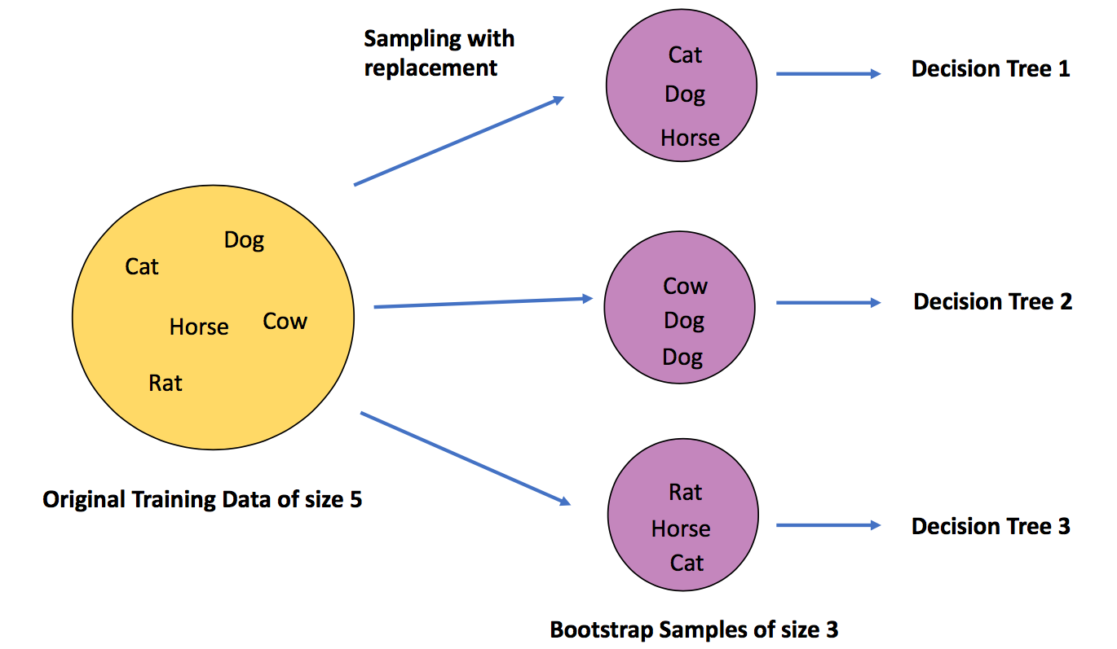

📌 How it Works:
- During Random Forest training, each tree is trained on a bootstrapped subset (random sampling with replacement).
- Some data points (around 37%) are not included in the training set; these are called

Out-of-Bag (OOB) samples.
- The model is evaluated on these OOB samples without requiring an explicit validation set.

💡 Usage:
- Provides a built-in validation mechanism for Random Forest.
- Reduces the need for traditional cross-validation.
- Helps in estimating model performance efficiently.

🔍 Key Differences:

Feature | Cross-Validation (CV) | Out-of-Bag (OOB) Score
Applicable To | Any ML model | Only for ensemble methods like Random Forest
Data Splitting | Explicitly divides dataset into folds | Uses samples not included in bootstrapped training
Computational Cost | Higher (multiple model training) | Lower (built-in during training)
Prevents Overfitting? | Yes | Yes
Best for? | General ML models | Random Forest & Bagging-based models

Classification Metrics in Machine Learning

When evaluating a classification model, different metrics help assess its performance. The choice of metric depends on the problem (binary classification, multi-class classification, imbalanced data, etc.).

- Accuracy

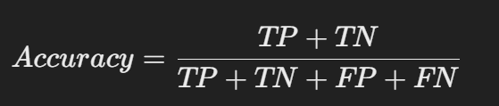

- Measures the percentage of correctly classified instances.
- Best for: Balanced datasets where False Positives (FP) and False Negatives (FN) have equal importance.
- Limitation: Not suitable for imbalanced datasets.

- Precision (Positive Predictive Value, PPV)



- Measures how many predicted positive cases are actually positive.
- Best for: When False Positives (FP) are costly (e.g., spam detection, medical diagnosis).

- Recall (Sensitivity, True Positive Rate, TPR)



- Measures how many actual positive cases were correctly identified.
- Best for: When False Negatives (FN) are costly (e.g., cancer detection, fraud detection).

- F1-Score (Harmonic Mean of Precision & Recall)

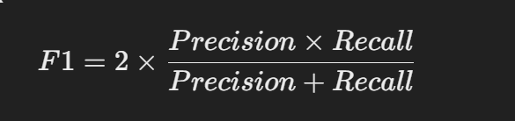
- Best for: Imbalanced datasets where both Precision and Recall are important.

- Specificity (True Negative Rate, TNR)



- Measures how well the model identifies negative cases.
- Best for: Problems where False Positives (FP) need to be minimized.

- ROC Curve (Receiver Operating Characteristic Curve) & AUC (Area Under the Curve)

- ROC Curve: Plots True Positive Rate (TPR) vs. False Positive Rate (FPR).
- AUC (Area Under Curve): Measures the ability of a classifier to distinguish between classes.
- Best for: Comparing different models' performance.

- Log Loss (Logarithmic Loss)

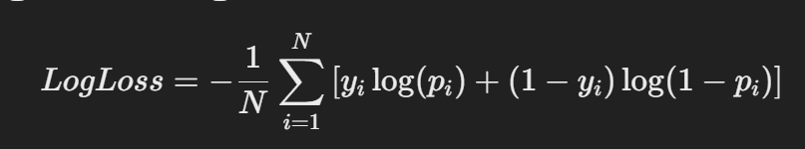

- Evaluates the probability estimates of classification models.
- Best for: Probabilistic classifiers like Logistic Regression, Neural Networks.

- Matthews Correlation Coefficient (MCC)

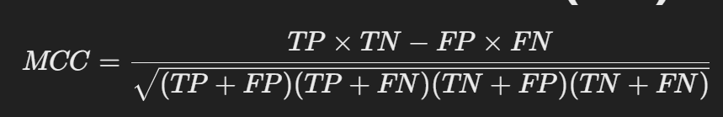

- A balanced measure for both imbalanced and balanced datasets.
- Best for: Highly imbalanced datasets.

- Cohen’s Kappa

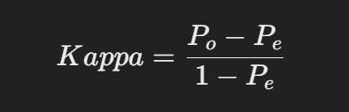

Where:
- Po = Observed Agreement
- Pe​ = Expected Agreement (by chance)
- Best for: Multi-class classification, inter-rater agreement problems.

🔹 Choosing the Right Metric
Scenario | Recommended Metric
Balanced dataset | Accuracy, F1-Score
Imbalanced dataset | Precision, Recall, F1-Score, MCC
Need probability-based evaluation | Log Loss, AUC-ROC
Cost of FP is high (e.g., spam filter) | Precision, Specificity
Cost of FN is high (e.g., medical diagnosis) | Recall

Curse of Dimensionality
📌 What is the Curse of Dimensionality?
The "Curse of Dimensionality" refers to the challenges and inefficiencies that arise when working with high-dimensional data. As the number of features (dimensions) increases, data becomes sparse, making it difficult for machine learning models to learn patterns effectively.

📌 Problems Caused by High Dimensions
- Increased Computational Complexity
  - More dimensions mean higher storage and computation costs.
  - Algorithms take longer to process data.
- Sparsity of Data
  - In high dimensions, data points spread out, making it difficult to find meaningful clusters.
  - Distance metrics (e.g., Euclidean distance) become less useful because all points appear equally far apart.
- Overfitting
  - More features increase the risk of overfitting since models may learn noise instead of patterns.
- Diminishing Data Density
  - In high-dimensional space, data points become sparse, requiring exponentially more samples to maintain the same density as in lower dimensions.

📌 Example: Distance Becomes Meaningless
Consider a dataset with points in 1D, 2D, and 100D space:
- In 1D, distances are well-separated.
- In 2D, points are still distinguishable.
- In 100D, distances between points become nearly the same, making it hard to differentiate them.

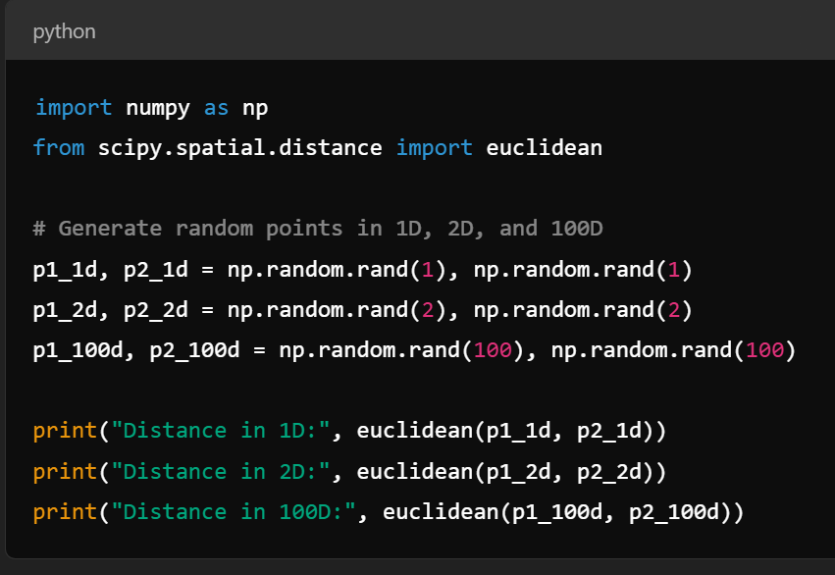
In high dimensions, distances tend to be similar, reducing their usefulness.

📌 How to Overcome the Curse of Dimensionality?
✅ Dimensionality Reduction Techniques
- PCA (Principal Component Analysis) – Projects data onto fewer dimensions.
- t-SNE (t-Distributed Stochastic Neighbor Embedding) – Preserves local relationships in lower dimensions.
- Autoencoders – Neural networks that learn compressed representations of data.
✅ Feature Selection
- Removing irrelevant or redundant features.
- Using statistical tests like Chi-Square or mutual information.
✅ Manifold Learning
- Techniques like t-SNE, UMAP find lower-dimensional manifolds in high-dimensional space.
📌 Key Takeaways
- High-dimensional data becomes sparse and distances lose meaning.
- Models may overfit due to excessive features.
- Use dimensionality reduction or feature selection to mitigate the problem.

Feature Transformation in Machine Learning

Feature transformation is the process of modifying features to improve a model's performance. It helps in handling skewed distributions, normalizing data, and making patterns more visible to machine learning algorithms.

Normalization (Min-Max Scaling)
- Rescales values between a fixed range [0,1] or [−1,1].
- Formula:
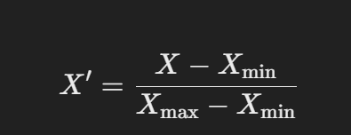

- Best for: Algorithms like KNN, Neural Networks, where features should be on a similar scale.

Standardization (Z-score Scaling)
- Converts features to have zero mean and unit variance.
- Formula:
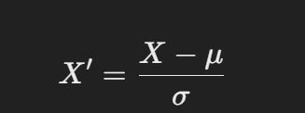

- where μ is the mean and σ is the standard deviation.
- Best for: Algorithms like SVM, Linear Regression, PCA.

Log Transformation
- Converts skewed data into a more normal distribution.
- Formula: 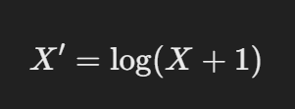
- Best for: Reducing the impact of extreme values (e.g., financial data, count data).
Power Transformation (Box-Cox & Yeo-Johnson)
- Adjusts skewed data to be more Gaussian-like.
- Box-Cox Transformation: Used for positive values only.
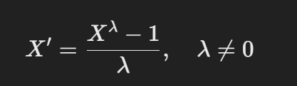
- Yeo-Johnson Transformation: Works for both positive and negative values.
- Best for: Data normalization when log transformation is not sufficient.

Polynomial Transformation
- Creates new features by combining existing ones using polynomial functions.
- Example (Degree 2)
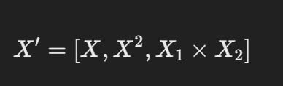

Binning (Discretization)
- Converts continuous features into categorical bins (e.g., age groups).
- Example:
  - Age 0-18 → "Child"
  - Age 19-35 → "Young Adult"
  - Age 36+ → "Adult"
- Best for: Decision Trees, rule-based models.

One-Hot Encoding
- Converts categorical variables into binary vectors.
- Example:
  - "Red", "Blue", "Green" → [1,0,0], [0,1,0], [0,0,1]
- Best for: Tree-based models, deep learning.

Target Encoding
- Replaces categorical values with the mean of the target variable.
- Example: If "City" is a feature and the target is house price:
  - Mumbai → 85 Lakhs
  - Delhi → 75 Lakhs
  - Bangalore → 80 Lakhs
- Best for: High-cardinality categorical variables in regression tasks.
Principal Component Analysis (PCA)
- Reduces dimensionality by finding new uncorrelated features (principal components).
- Best for: High-dimensional datasets to remove redundant features.

🔹 Choosing the Right Transformation
Problem | Recommended Transformation
Features have different scales | Normalization, Standardization
Skewed data | Log Transformation, Power Transformation
High-dimensional data | PCA
Non-linearity in data | Polynomial Features
Categorical data | One-Hot Encoding, Target Encoding

Feature Selection

Feature selection is the process of identifying the most relevant features (independent variables) for a machine learning model to improve performance, reduce overfitting, and decrease computation time.

Techniques for Feature Selection:
- Filter Methods
  - Uses statistical tests to rank features based on their relationship with the target variable.
  - Examples: Correlation coefficient, Chi-Square test, Mutual Information.
- Wrapper Methods
  - Evaluates different feature subsets using a machine learning model.
  - Examples: Forward Selection, Backward Elimination, Recursive Feature Elimination (RFE).
- Embedded Methods
  - Feature selection is built into the model training process.
  - Examples: Lasso Regression (L1 Regularization), Decision Tree-based feature importance.
- Dimensionality Reduction Methods
  - Transforms the feature space to a lower-dimensional representation.
  - Examples: Principal Component Analysis (PCA), Linear Discriminant Analysis (LDA).

Imabalanced Dataset and its effect on Classification
- Bias Towards the Majority Class:
  - Classification algorithms are designed to maximize overall accuracy. In an imbalanced dataset, the model may achieve high accuracy by simply predicting the majority class for all instances, ignoring the minority class.
  - Example: In a dataset with 95% negative class and 5% positive class, a model that always predicts the negative class will achieve 95% accuracy, but it fails to identify the positive class.
- Poor Generalization for Minority Class:
  - The model may not learn meaningful patterns for the minority class because it is underrepresented in the training data.
  - This leads to poor recall (ability to correctly identify minority class instances) and F1-score (balance between precision and recall).
- Misleading Evaluation Metrics:
  - Accuracy is not a reliable metric for imbalanced datasets. A high accuracy score may hide the fact that the model is performing poorly on the minority class.
  - Example: A model with 98% accuracy might be failing to detect 90% of the minority class instances.
- Overfitting to the Majority Class:
  - The model may overfit to the majority class, as it has more examples to learn from, while underfitting the minority class.
- Difficulty in Learning Decision Boundaries:
  - Imbalanced datasets can make it challenging for the model to learn the true decision boundary between classes, especially if the minority class is sparse or overlaps with the majority class.
- Impact on Model Training:
  - Many machine learning algorithms assume balanced class distributions. When this assumption is violated, the model may not converge properly or may prioritize the majority class during optimization.

Why Imbalanced Datasets Are Problematic
- Real-World Consequences:
  - In many applications (e.g., fraud detection, disease diagnosis), the minority class is often the class of interest. Failing to predict it correctly can have serious consequences.
  - Example: In medical diagnosis, failing to detect a disease (false negatives) is more critical than incorrectly diagnosing a healthy patient (false positives).
- Skewed Class Distribution:
  - The model's predictions may not reflect the true underlying distribution of the data, leading to poor decision-making.

Bias Variance Tradeoff

The bias-variance tradeoff is a fundamental concept in machine learning that describes the relationship between a model's complexity, its ability to fit the training data, and its ability to generalize to unseen data. Understanding this tradeoff is crucial for building models that perform well on both the training and test datasets.

Key Concepts
- Bias:
  - Definition: Bias refers to the error introduced by approximating a real-world problem, which may be complex, by a simplified model.
  - High Bias: A model with high bias pays little attention to the training data and oversimplifies the problem. This leads to underfitting, where the model performs poorly on both the training and test data.
  - Example: Linear regression applied to a non-linear dataset.
- Variance:
  - Definition: Variance refers to the error introduced by the model's sensitivity to small fluctuations in the training data.
  - High Variance: A model with high variance pays too much attention to the training data, capturing noise and outliers. This leads to overfitting, where the model performs well on the training data but poorly on the test data.
  - Example: A high-degree polynomial regression that fits the training data perfectly but fails to generalize.
- Irreducible Error:
  - This is the error caused by noise or inherent randomness in the data. It cannot be reduced by any model.
Bias-Variance Tradeoff
The bias-variance tradeoff is the balance between:
- Bias: How well the model captures the underlying pattern in the data.
- Variance: How sensitive the model is to changes in the training data.
The goal is to find a model with the right level of complexity that minimizes the total error (bias + variance + irreducible error).

Mathematical Representation
The total error of a model can be decomposed as follows:
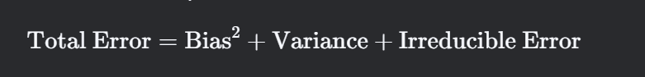
- Bias²: Measures how far the model's predictions are from the true values on average.
- Variance: Measures how much the model's predictions fluctuate for different training datasets.
- Irreducible Error: The inherent noise in the data.

Visualizing Bias and Variance
- Low Bias, Low Variance:
  - The model fits the training data well and generalizes to unseen data.
  - Ideal scenario.
- High Bias, Low Variance:
  - The model is too simple and underfits the data.
  - Example: A straight line fitting a non-linear dataset.
- Low Bias, High Variance:
  - The model is too complex and overfits the data.
  - Example: A high-degree polynomial fitting a dataset with noise.
- High Bias, High Variance:
  - The model is both too simple and too sensitive to the training data.
  - Rare but can occur in poorly designed models.

How to Manage the Bias-Variance Tradeoff
- Increase Model Complexity (Reduce Bias):
  - Use more complex models (e.g., higher-degree polynomials, deeper decision trees).
  - Add more features to the model.
  - Be cautious: Increasing complexity can lead to overfitting (high variance).
- Decrease Model Complexity (Reduce Variance):
  - Use simpler models (e.g., linear regression instead of polynomial regression).
  - Reduce the number of features (feature selection).
  - Regularization techniques (e.g., L1/L2 regularization) can penalize complex models.
- Cross-Validation:
  - Use techniques like k-fold cross-validation to evaluate the model's performance on multiple subsets of the data.
  - Helps in selecting the right level of model complexity.
- Ensemble Methods:
  - Combine multiple models to balance bias and variance.
  - Example: Bagging (reduces variance) and Boosting (reduces bias).
- Regularization:
  - Add a penalty term to the loss function to constrain the model's complexity.
  - L1 regularization (Lasso) encourages sparsity.
  - L2 regularization (Ridge) discourages large weights.
- More Training Data:
  - Increasing the size of the training dataset can help reduce variance, as the model has more examples to learn from.
- Early Stopping:
  - Stop training when the validation error starts to increase, preventing overfitting.
Examples of Bias-Variance Tradeoff
- Linear Regression:
  - High bias: Assumes a linear relationship, which may not capture complex patterns.
  - Low variance: Simple model, less sensitive to small changes in data.
- Decision Trees:
  - Low bias: Can capture complex patterns.
  - High variance: Prone to overfitting, especially with deep trees.
- Random Forest:
  - Reduces variance by averaging multiple decision trees.
  - Balances bias and variance effectively.
- Neural Networks:
  - Low bias: Can model highly complex relationships.
  - High variance: Prone to overfitting without proper regularization or sufficient data.

📌 Machine Learning Resources
- 🔗 Machine Learning Mastery – Getting Started with ML
https://machinelearningmastery.com/start-here/
- 🔗 Scikit-Learn Official Documentation
https://scikit-learn.org/stable/user_guide.html
- 🔗 GeeksforGeeks – Introduction to Machine Learning
https://www.geeksforgeeks.org/introduction-machine-learning/
- 🔗 GeeksforGeeks – Supervised vs. Unsupervised Learning
https://www.geeksforgeeks.org/supervised-unsupervised-learning/
- 🔗 GeeksforGeeks – Supervised Machine Learning
https://www.geeksforgeeks.org/supervised-machine-learning/
- 🔗 Understanding Cross-Validation (Scikit-Learn):
https://scikit-learn.org/stable/modules/cross_validation.html
- 🔗 Out-of-Bag (OOB) Error in Random Forest (Scikit-Learn):
https://scikit-learn.org/stable/auto_examples/ensemble/plot_ensemble_oob.html
- Classification Metrics in ML (Scikit-Learn):
https://scikit-learn.org/stable/modules/model_evaluation.html
- Confusion Matrix Explained (GeeksforGeeks):
https://www.geeksforgeeks.org/confusion-matrix-machine-learning/

- Important Interview Questions on Introduction to Machine Learning

1️ What is Machine Learning?
Answer:
Machine Learning (ML) is a subset of Artificial Intelligence (AI) that enables computers to learn patterns from data and make decisions without explicit programming.
✅ Example: Predicting house prices based on past sales data.

2️ What are the main types of Machine Learning?
Answer: Machine Learning is categorized into five types:

1. Supervised Learning
- Definition: Model learns from labeled data (i.e., input-output pairs).
- Example: Email spam detection (Spam or Not Spam).
- Common Algorithms:
  - Linear Regression
  - Logistic Regression
  - Decision Trees
  - Random Forest

2. Unsupervised Learning
- Definition: Model learns patterns from unlabeled data.
- Example: Customer segmentation for marketing.
- Common Algorithms:
  - K-Means Clustering
  - Hierarchical Clustering
  - Principal Component Analysis (PCA)

3. Semi-Supervised Learning
- Definition: Model is trained on a small amount of labeled data + a large amount of unlabeled data.
- Example: Identifying fake news when only a few labeled examples are available.

4. Self-Supervised Learning
- Definition: Model generates its own labels using data itself.
- Example: Pre-training language models like GPT by predicting missing words in sentences.

5. Reinforcement Learning (RL)
- Definition: Model learns by interacting with an environment and receiving rewards or penalties.
- Example: Training a robot to walk by rewarding correct movements.
- Key Algorithms:
  - Q-Learning
  - Deep Q Networks (DQN)
  - Policy Gradient Methods

6.What is a Regression Problem in General?
Answer: Regression is a Supervised Learning technique where the goal is to predict continuous numerical values.

✅ Example: Predicting temperature based on past weather data.
Common Regression Algorithms:
- Linear Regression – Simple relationship between input and output.
- Polynomial Regression – Models complex relationships.
- Decision Tree Regression – Captures non-linear patterns.

7.What is a Classification Problem in General?
Answer: Classification is a Supervised Learning technique where the goal is to predict discrete categories or labels.

✅ Example: Identifying whether an email is Spam or Not Spam.
Common Classification Algorithms:
- Logistic Regression – Used for binary classification.
- Decision Trees & Random Forest – Handles complex, non-linear data.
- Support Vector Machines (SVM) – Works well for high-dimensional data.

Validation Techniques: CV, OOB

What is Cross-Validation (CV), and why is it used in machine learning?
Cross-Validation is a technique used to evaluate the performance of a machine learning model by partitioning the dataset into multiple subsets, training the model on some subsets, and validating it on the remaining subsets. It is used to:
- Assess how well the model generalizes to unseen data.
- Reduce overfitting by providing a more robust evaluation of the model.
- Optimize hyperparameters.

Explain different types of cross-validation techniques.
- K-Fold Cross-Validation: The dataset is split into K subsets (folds). The model is trained on K-1 folds and validated on the remaining fold. This process is repeated K times.
- Stratified K-Fold Cross-Validation: Ensures that each fold maintains the same proportion of target classes as the original dataset.
- Leave-One-Out Cross-Validation (LOOCV): A special case of K-Fold where K equals the number of samples. Each sample is used as a validation set once.
- Hold-Out Validation: The dataset is split into a training set and a validation set (e.g., 80-20 split).
- Time Series Cross-Validation: Used for time-dependent data, where the model is trained on past data and validated on future data.

What is K-Fold Cross-Validation, and how does it work?
K-Fold Cross-Validation splits the dataset into K equal-sized folds. The model is trained on K-1 folds and validated on the remaining fold. This process is repeated K times, with each fold used exactly once as the validation set. The final performance metric is the average of the K validation results.

How does Stratified K-Fold Cross-Validation differ from regular K-Fold?
Stratified K-Fold ensures that each fold has the same proportion of target classes as the original dataset. This is particularly useful for imbalanced datasets, where regular K-Fold might result in folds with no representation of minority classes.

What is Leave-One-Out Cross-Validation (LOOCV), and when should it be used?
LOOCV is a special case of K-Fold Cross-Validation where K equals the number of samples. Each sample is used as a validation set once, and the model is trained on the remaining samples. It is useful for small datasets but computationally expensive for large datasets.

What is Out-of-Bag (OOB) error in Random Forest, and how is it different from cross-validation?
OOB error is an estimate of the model's performance using the samples not included in the bootstrap sample (out-of-bag samples) for each tree in a Random Forest. Unlike cross-validation, OOB error is computed internally during training and does not require a separate validation set.

Why is OOB error useful in ensemble methods like Random Forest?
OOB error provides an unbiased estimate of the model's performance without the need for a separate validation set. It is computationally efficient and helps in tuning hyperparameters like the number of trees.

Different Types of Metrics for Classification

What are the common evaluation metrics for classification problems?
Common metrics include:
- Accuracy
- Precision
- Recall
- F1-Score
- ROC-AUC
- Log Loss
- Confusion Matrix

What is accuracy, and why is it not always a reliable metric?
Accuracy is the ratio of correctly predicted instances to the total instances. It is not reliable for imbalanced datasets because it can be misleadingly high if the majority class dominates.

Explain the difference between precision, recall, and F1-score.
- Precision: Measures the proportion of true positives among all predicted positives (TP / (TP + FP)).
- Recall: Measures the proportion of true positives among all actual positives (TP / (TP + FN)).
- F1-Score: The harmonic mean of precision and recall, balancing both metrics.

What is the significance of the confusion matrix?
A confusion matrix provides a detailed breakdown of true positives, true negatives, false positives, and false negatives. It helps in understanding the model's performance across different classes.

How does ROC-AUC help in evaluating classification models?
ROC-AUC (Receiver Operating Characteristic - Area Under Curve) measures the model's ability to distinguish between classes. A higher AUC indicates better performance. It is useful for evaluating models on imbalanced datasets.
What is log loss, and when should it be used?
Log loss measures the performance of a classification model by penalizing incorrect predictions. It is used when the model outputs probabilities, and a lower log loss indicates better performance.

Explain the difference between micro, macro, and weighted averaging in multi-class classification.
- Micro-Averaging: Aggregates the contributions of all classes to compute the average metric.
- Macro-Averaging: Computes the metric independently for each class and then takes the average.
- Weighted-Averaging: Similar to macro-averaging but weights the average by the number of samples in each class.

Curse of Dimensionality

What is the curse of dimensionality, and how does it affect machine learning models?
The curse of dimensionality refers to the challenges that arise when working with high-dimensional data, such as increased sparsity, computational complexity, and overfitting.

How does high dimensionality impact distance-based algorithms like KNN?
In high-dimensional spaces, distances between points become less meaningful, making it difficult for distance-based algorithms like KNN to distinguish between neighbors.

What are some techniques to handle the curse of dimensionality?
- Feature selection
- Dimensionality reduction (e.g., PCA, t-SNE)
- Regularization
- Increasing the dataset size

How does dimensionality reduction help in solving this problem?
Dimensionality reduction techniques like PCA reduce the number of features while retaining the most important information, improving model performance and interpretability.

Explain why adding more features does not always improve model performance.
Adding irrelevant or redundant features can increase noise, overfitting, and computational complexity without improving model performance.

Feature Transformations

What is feature transformation in machine learning?
Feature transformation involves modifying the features to improve model performance, such as scaling, encoding, or applying mathematical transformations.

What is the difference between normalization and standardization?
- Normalization: Scales features to a range (e.g., [0, 1]).
- Standardization: Scales features to have a mean of 0 and a standard deviation of 1.

When should you use log transformation, and why?
Log transformation is used for data with exponential growth or heavy-tailed distributions to reduce skewness and make the data more normally distributed.

How does one-hot encoding differ from label encoding?
- One-Hot Encoding: Creates binary columns for each category.
- Label Encoding: Assigns a unique integer to each category.

What is the purpose of power transformations like Box-Cox and Yeo-Johnson?
Power transformations stabilize variance, make data more normally distributed, and improve the performance of linear models.

Feature Selection

What is feature selection, and why is it important in machine learning?
Feature selection involves selecting the most relevant features to improve model performance, reduce overfitting, and decrease computational cost.

Explain the difference between filter, wrapper, and embedded feature selection methods.
- Filter Methods: Use statistical measures to select features (e.g., correlation).
- Wrapper Methods: Use a model to evaluate feature subsets (e.g., RFE).
- Embedded Methods: Perform feature selection during model training (e.g., Lasso).

What is Recursive Feature Elimination (RFE), and how does it work?
RFE recursively removes the least important features based on model performance until the desired number of features is reached.

How does L1 regularization (Lasso) perform feature selection?
L1 regularization adds a penalty equal to the absolute value of the coefficients, forcing some coefficients to zero, effectively selecting features.

What are some feature selection techniques used in tree-based models?
- Feature importance scores
- Gain, cover, and frequency in gradient boosting models

Imbalanced Dataset and Its Effect on Classification

What is an imbalanced dataset, and how does it affect model performance?
An imbalanced dataset has uneven distribution of classes, leading to biased models that favor the majority class.
Why is accuracy not a reliable metric for imbalanced datasets?
Accuracy can be high even if the model predicts only the majority class, ignoring the minority class.

What are some techniques to handle data imbalance?
- Oversampling (e.g., SMOTE)
- Undersampling
- Class weighting
- Synthetic data generation

How does SMOTE (Synthetic Minority Over-sampling Technique) work?
SMOTE generates synthetic samples for the minority class by interpolating between existing samples.

What are the advantages and disadvantages of oversampling and undersampling?
- Oversampling: Increases the size of the minority class but may cause overfitting.
- Undersampling: Reduces the size of the majority class but may lose important information.

Bias-Variance Tradeoff

What is the bias-variance tradeoff in machine learning?
The bias-variance tradeoff refers to the balance between underfitting (high bias) and overfitting (high variance).

How does high bias affect a model's performance?
High bias leads to underfitting, where the model is too simple and performs poorly on both training and test data.

How does high variance lead to overfitting?
High variance leads to overfitting, where the model is too complex and performs well on training data but poorly on test data.

What are some techniques to reduce bias and variance?
- Reduce Bias: Increase model complexity, add features, or use a more advanced algorithm.
- Reduce Variance: Simplify the model, use regularization, or increase training data.
How does cross-validation help in addressing bias-variance issues?
Cross-validation provides a more robust estimate of model performance, helping to identify and balance bias and variance.

